1. How many processes are created when the following program is run?
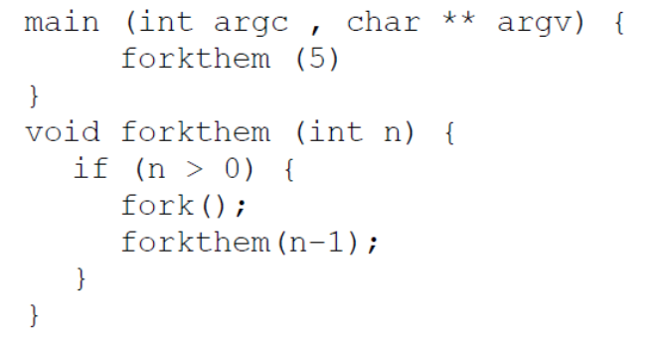
2.
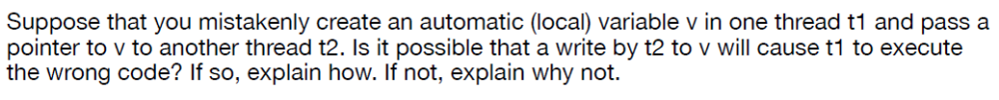
3.
4.
5.
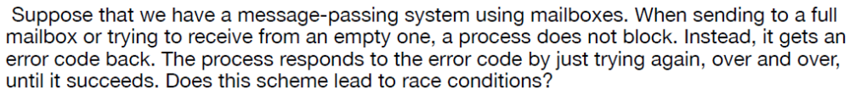

6. How many different copies of the variable x are there in the following? What are their values when their process finishes?
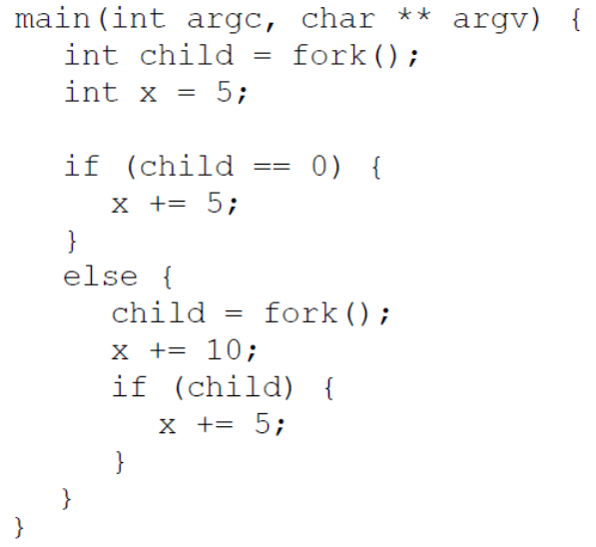

7.
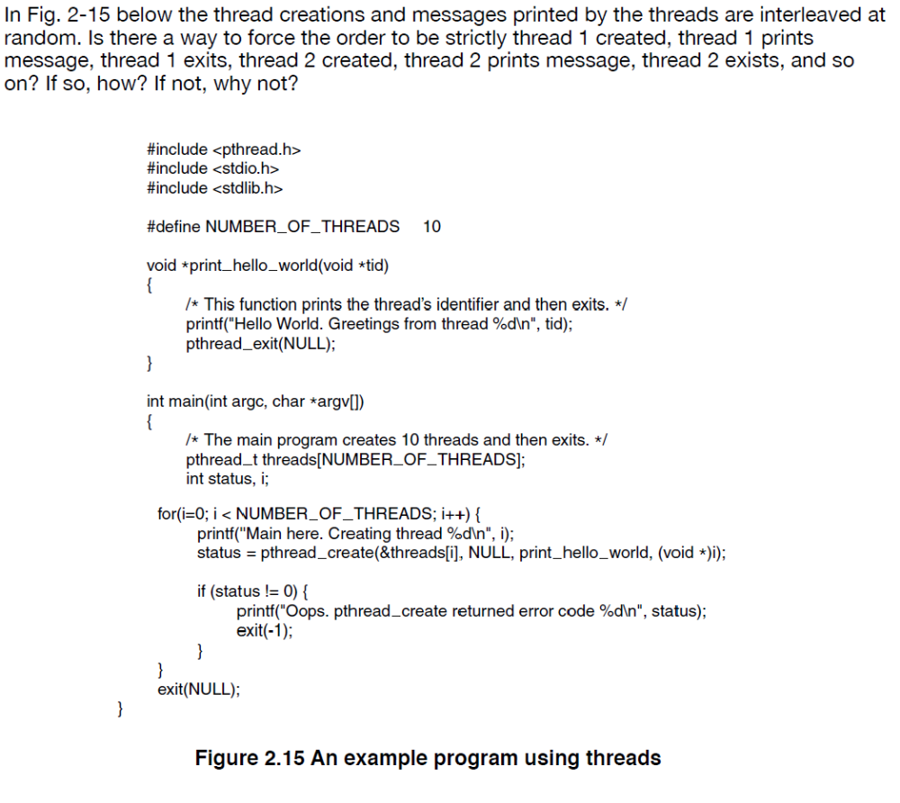
8. What is the output of the following programs?

